**HOMEWORK 1**

**Name:** Trần Minh Quân

**ID:** 19151078

Contents

1. Given set A and B as follow: 2

a) Calculate 𝐴 ∩ 𝐵 using MIN and PROD 2

b) Calculate 𝐴 ∪ 𝐵 using MAX and SUM 3

2. Given set A and B as follow: 4

a) Calculate 𝐴 ∩ 𝐵 using MIN and PROD 4

b) Calculate 𝐴 ∪ 𝐵 using MAX and SUM 5

3. Given set A and B in X’s dimension and set C and D in Y’s dimension. 6

a) Calculate 𝐴 ∩ 𝐵 using MIN and PROD 6

b) Calculate 𝐴 ∩ 𝐶 using MIN and PROD 6

Figure 1: Set A and B 3

Figure 2: Graph A and B 5

# Given set A and B as follow:

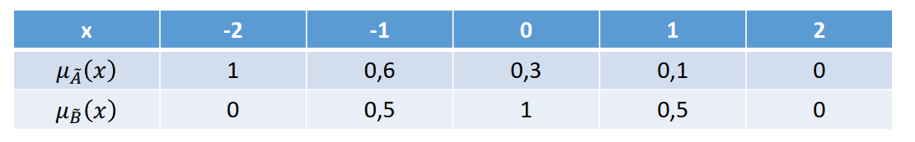

Figure : Set A and B

## Calculate 𝐴 ∩ 𝐵 using MIN and PROD

|  |  |  |  |  |  |
| --- | --- | --- | --- | --- | --- |
| x | -2 | -1 | 0 | 1 | 2 |
| $$u_{\tilde{A}}(x)$$ | 1 | 0.6 | 0.3 | 0.1 | 0 |
| $$μ_{\tilde{B}}(x)$$ | 0 | 0.5 | 1 | 0.5 | 0 |
| MIN | 0 | 0.5 | 0.3 | 0.1 | 0 |
| PROD | 0 | 0.3 | 0.3 | 0.05 | 0 |

## Calculate 𝐴 ∪ 𝐵 using MAX and SUM

|  |  |  |  |  |  |
| --- | --- | --- | --- | --- | --- |
| x | -2 | -1 | 0 | 1 | 2 |
| $$μ_{\tilde{A}}(x)$$ | 1 | 0.6 | 0.3 | 0.1 | 0 |
| $$μ_{\tilde{B}}(x)$$ | 0 | 0.5 | 1 | 0.5 | 0 |
| Max | 1 | 0.6 | 1 | 0.5 | 0 |
| Sum | 1 | 1 | 1 | 0.6 | 0 |

# Given set A and B as follow:

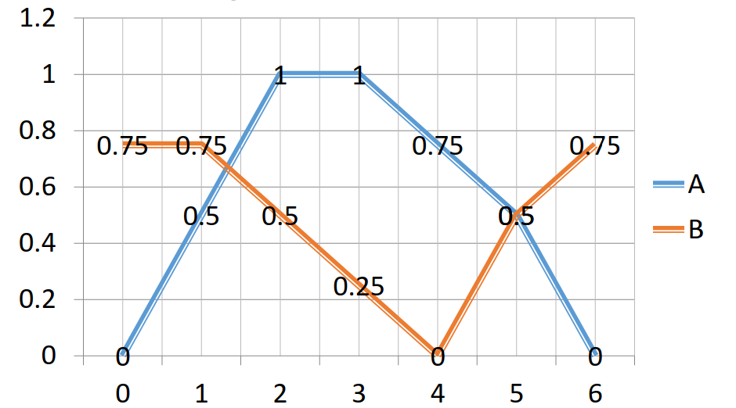

Figure : Graph A and B

## Calculate 𝐴 ∩ 𝐵 using MIN and PROD

|  |  |  |  |  |  |  |  |
| --- | --- | --- | --- | --- | --- | --- | --- |
| x | 0 | 1 | 2 | 3 | 4 | 5 | 6 |
| $$μ_{\tilde{A}}(x)$$ | 0 | 0.5 | 1 | 1 | 0.75 | 0.5 | 0 |
| $$μ_{\tilde{B}}(x)$$ | 0.75 | 0.75 | 0.5 | 0.25 | 0 | 0.5 | 0.75 |
| Min | 0 | 0.5 | 0.5 | 0.25 | 0 | 0.5 | 0 |
| Prod | 0 | 0.375 | 0.5 | 0.25 | 0 | 0.25 | 0 |

## Calculate 𝐴 ∪ 𝐵 using MAX and SUM

|  |  |  |  |  |  |  |  |
| --- | --- | --- | --- | --- | --- | --- | --- |
| x | 0 | 1 | 2 | 3 | 4 | 5 | 6 |
| $$μ_{\tilde{A}}(x)$$ | 0 | 0.5 | 1 | 1 | 0.75 | 0.5 | 0 |
| $$μ_{\tilde{A}}(x)$$ | 0.75 | 0.75 | 0.5 | 0.25 | 0 | 0.5 | 0.75 |
| Max | 0.75 | 0.75 | 1 | 1 | 0.75 | 0.5 | 0.75 |
| Sum | 0.75 | 1 | 1 | 1 | 0.75 | 1 | 0.75 |

# Given set A and B in X’s dimension and set C and D in Y’s dimension.

## Calculate 𝐴 ∩ 𝐵 using MIN and PROD

|  |  |  |  |  |  |
| --- | --- | --- | --- | --- | --- |
| x | -2 | -1 | 0 | 1 | 2 |
| $$μ_{\tilde{A}}(x)$$ | 1 | 0.6 | 0.3 | 0.1 | 0 |
| $$μ_{\tilde{B}}(x)$$ | 0 | 0.5 | 1 | 0.5 | 0 |
| MIN | 0 | 0.5 | 0.3 | 0.1 | 0 |
| PROD | 0 | 0.3 | 0.3 | 0.05 | 0 |

## Calculate 𝐴 ∩ 𝐶 using MIN and PROD

|  |  |  |  |  |  |
| --- | --- | --- | --- | --- | --- |
| x | -2 | -1 | 0 | 1 | 2 |
| y | 1 | 2 | 3 | 4 | 5 |
| $$μ_{\tilde{A}}(x)$$ | 1 | 0.6 | 0.3 | 0.1 | 0 |
| $$μ_{\tilde{C}}(x)$$ | 0 | 0.5 | 1 | 1 | 0.5 |

MIN:

|  |  |  |  |  |  |
| --- | --- | --- | --- | --- | --- |
| y\x | -2 | -1 | 0 | 1 | 2 |
| 1 | 0 | 0 | 0 | 0 | 0 |
| 2 | 0.5 | 0.5 | 0.3 | 0.1 | 0 |
| 3 | 1 | 0.6 | 0.3 | 0.1 | 0 |
| 4 | 1 | 0.6 | 0.3 | 0.1 | 0 |
| 5 | 0.5 | 0.5 | 0.3 | 0.1 | 0 |

PROD:

|  |  |  |  |  |  |
| --- | --- | --- | --- | --- | --- |
| y\x | -2 | -1 | 0 | 1 | 2 |
| 1 | 0 | 0 | 0 | 0 | 0 |
| 2 | 0.5 | 0.3 | 0.15 | 0.05 | 0 |
| 3 | 1 | 0.6 | 0.3 | 0.1 | 0 |
| 4 | 1 | 0.6 | 0.3 | 0.1 | 0 |
| 5 | 0.5 | 0.3 | 0.15 | 0.05 | 0 |